NETWORK SCAN REPORT
Using Nmap

Submitted By:
Name: Tirthkumar Harishbhai Patel
Internship: Security Analyst Internship
Organization: Oasis Infobyte
Date: 21/05/2026

1. Objective
The objective of this practical was to understand how Nmap works and perform network scanning in Kali Linux. The task included finding the system IP address, scanning ports, detecting services, identifying devices in the local network, and saving scan results.

2. Installation of Nmap
First, Nmap installation was verified.
Command:
sudo apt install nmap
Result:
Nmap was already installed in the system.

3. Finding System IP Address
Command used:
ifconfig
Detected IP Address:
192.168.1.14
This IP address was used for further scanning.

4. Basic Host Scan
Command:
nmap 192.168.1.14
Observation:
- Host was active.
- No ports responded.
- Filtered ports were detected.
Result:
Host is up
1000 filtered TCP ports

5. Service Version Detection
Command:
nmap -sV 192.168.1.14
Observation:
- Service detection was attempted.
- No services were identified because ports were filtered.

6. Aggressive Scan
Command:
nmap -A 192.168.1.14
Observation:
- OS detection was attempted.
- Network distance showed 0 hops.
- Exact operating system information could not be identified.

7. Fast Timing Scan
Command:
nmap -T4 192.168.1.14
Observation:
- Scan completed faster.
- Host remained active.
- Ports remained filtered.

8. Network Discovery Fast Scan
Command:
nmap -T4 192.168.1.0/24
Detected Devices:
Device: 192.168.1.1
Open Ports:
53 DNS
80 HTTP
443 HTTPS
Filtered:
23 Telnet

Device: 192.168.1.2
Open Ports:
80 HTTP
554 RTSP
8600 Asterisk

Device: 192.168.1.3
No open ports found.

Device: 192.168.1.7
No open ports found.

Device: 192.168.1.12
Ports filtered.

Device: 192.168.1.14
Host active but ports filtered.

9. Port Range Scan
Command:
nmap -p 1-1000 192.168.1.14
Observation:
- Ports from 1 to 1000 were scanned.
- Host responded successfully.
- Ports remained filtered.
Network Port Scan:
nmap -p 1-1000 192.168.1.0/24
Observation:
- Multiple devices were identified.
- Web services like HTTP and HTTPS were detected.
- Some systems blocked responses.

10. Saving Results into File
Command:
nmap -sV 192.168.1.14 -oN nmap_scan_results.txt
Purpose:
This command saves scan results into a text file.
To open saved results:
cat nmap_scan_results.txt
Result:
Scan results were successfully stored and viewed.
11. Results
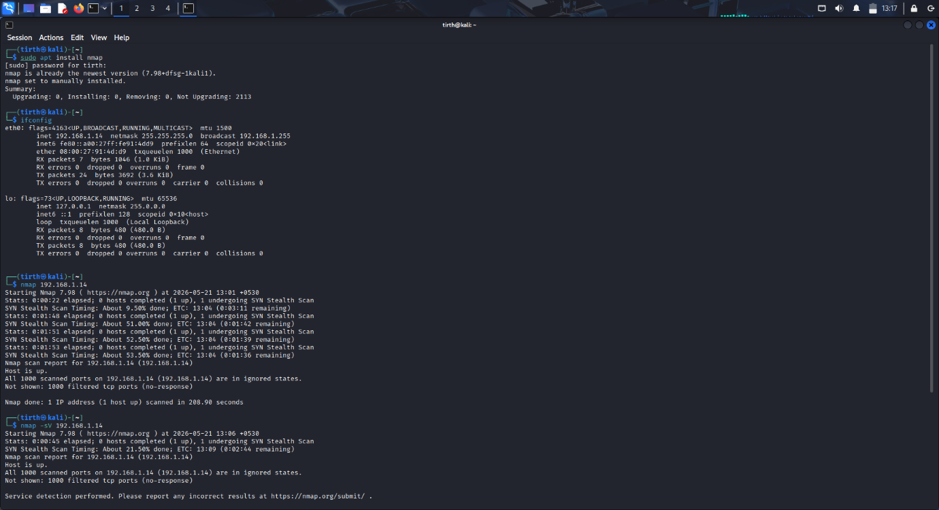

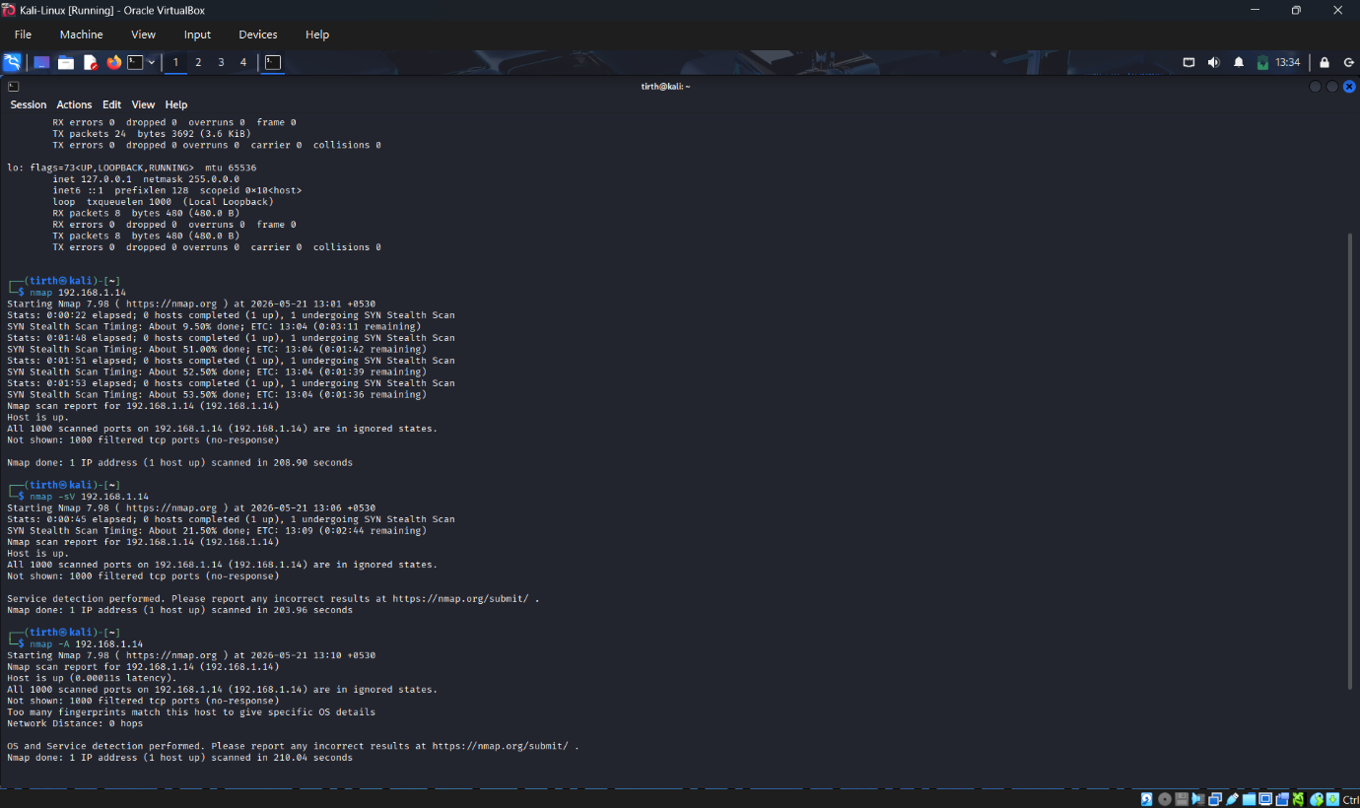

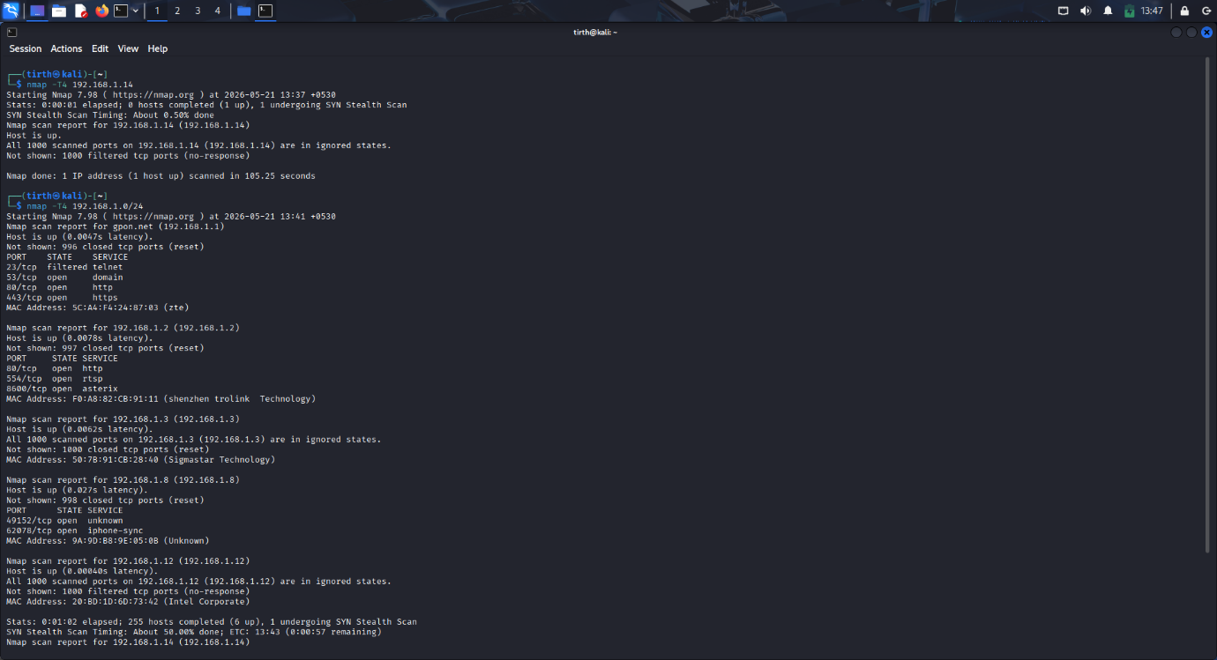

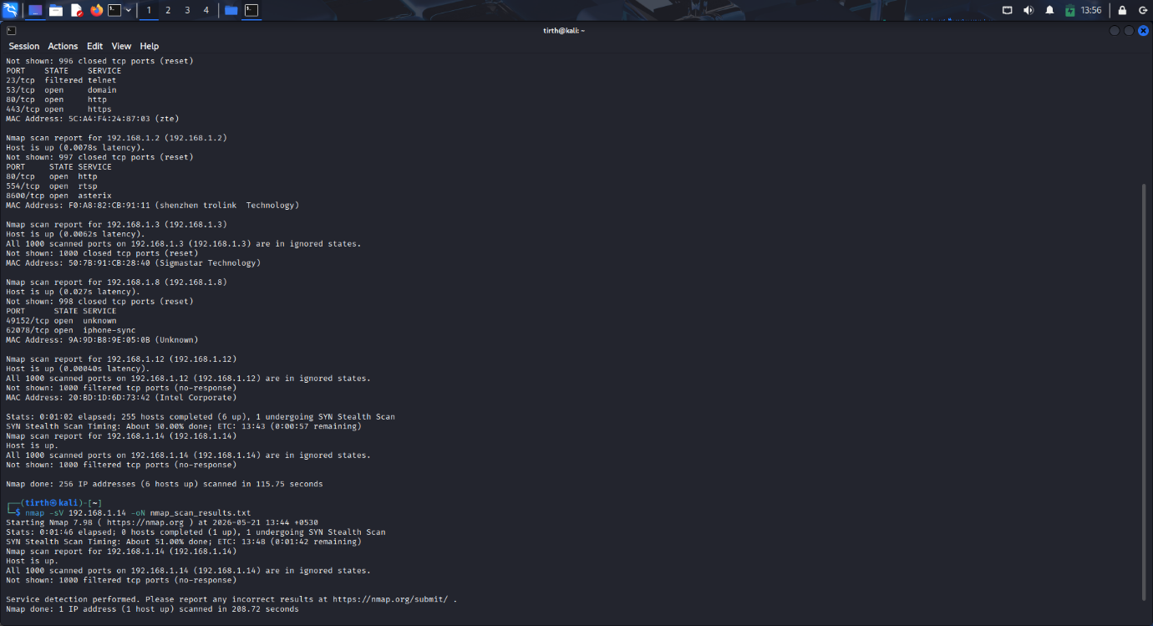

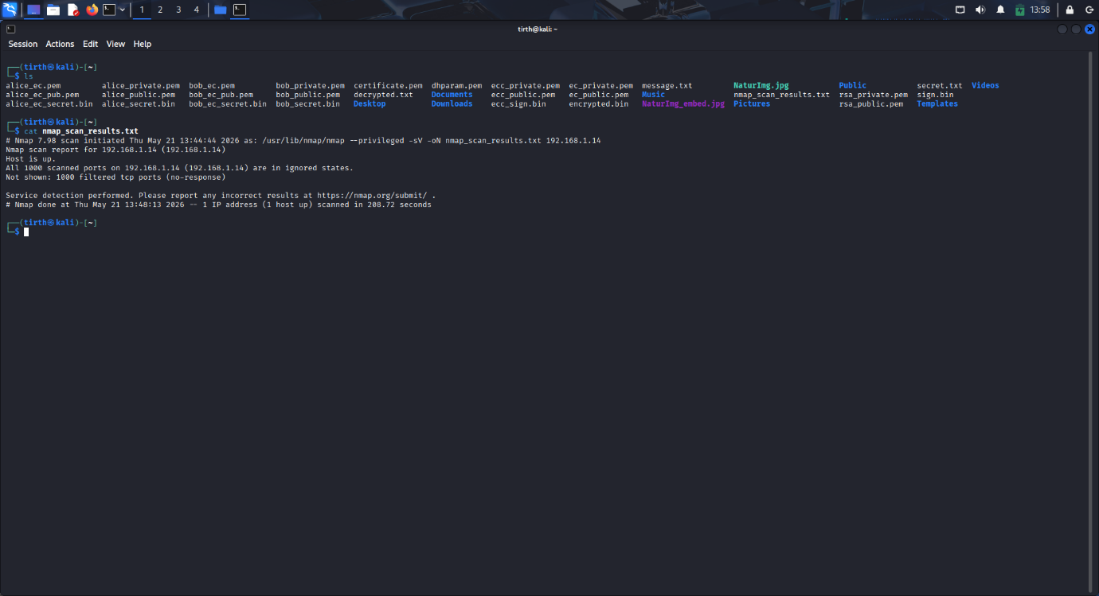
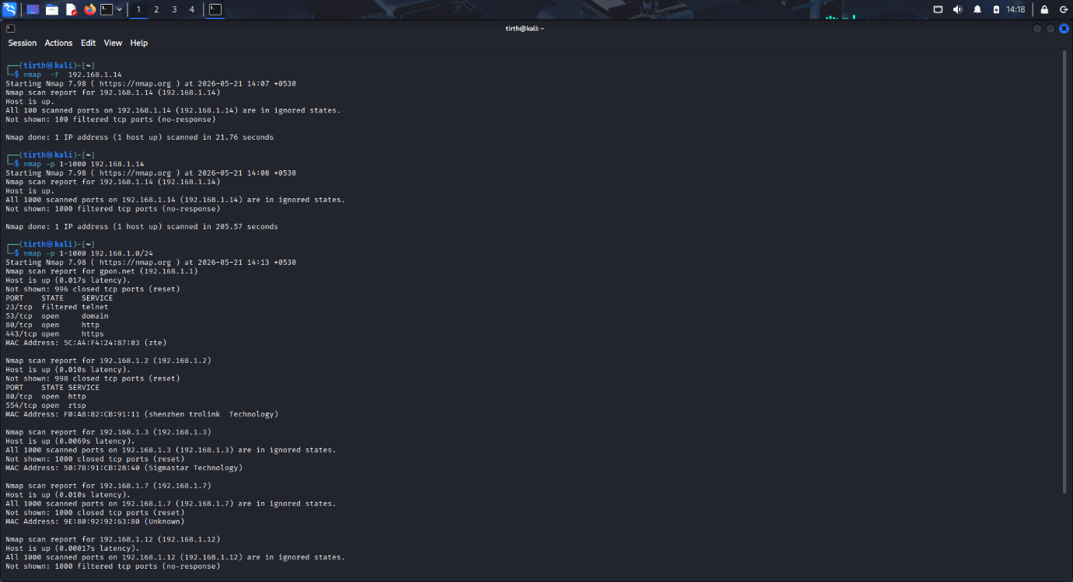

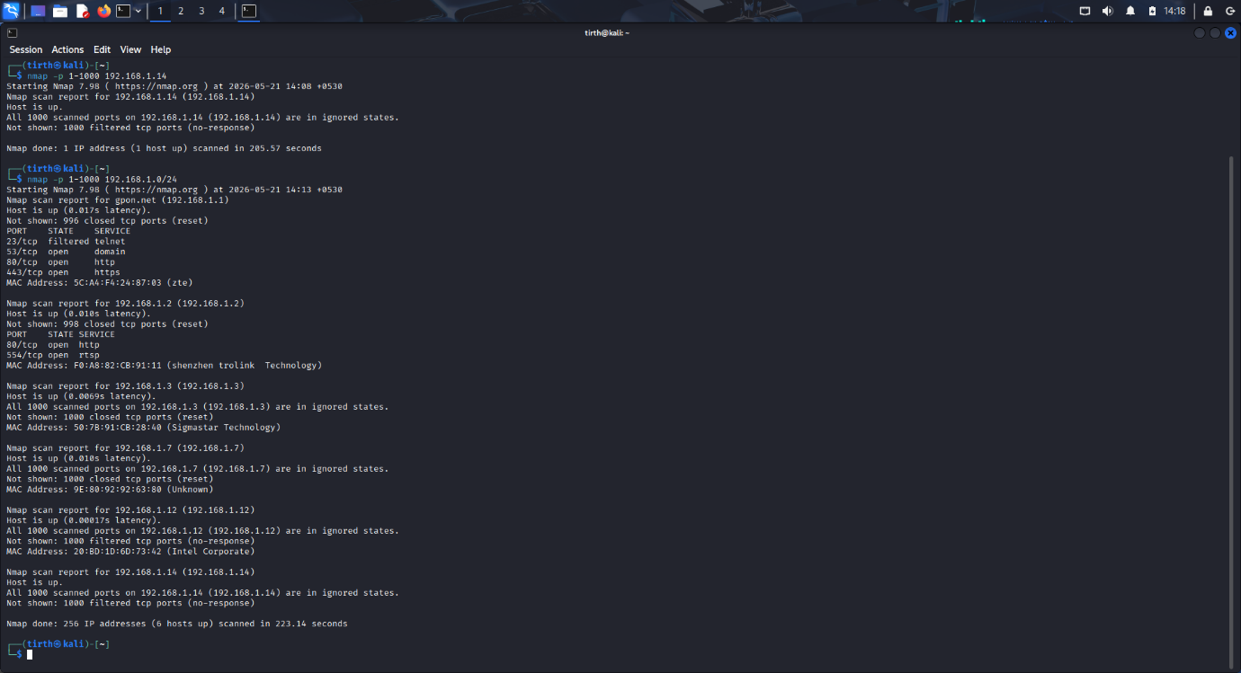

12. Conclusion
This practical helped understand how Nmap is used for network scanning and security analysis. Different types of scans were performed successfully including host scan, service detection, aggressive scan, network scan, and port range scan. Active devices and services were identified in the local network. Scan results were also stored successfully in a text file.
Nmap proved useful for discovering devices, identifying services, and understanding network behavior.

